NAME : AMITAB

ROLL NO: BIT-24S-028

SEMESTER: 3rd BSIT

SUBAJECT: ARTIFICIAL INTELLIGENCE

LAB TASK NO: 07

Task 1:

Write a function that takes two numbers and returns their product.

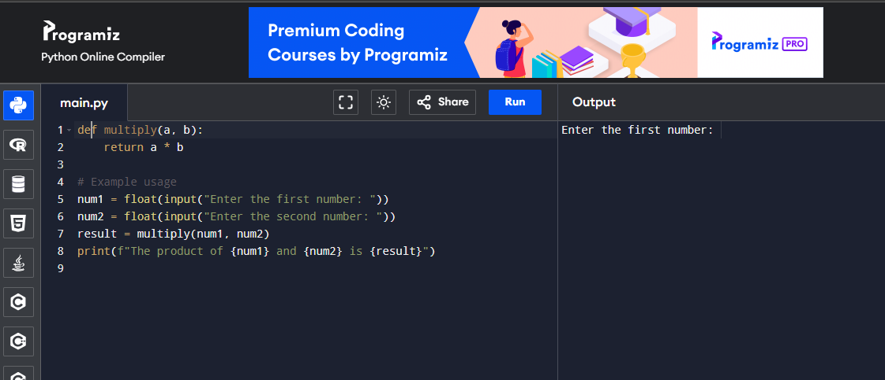

Task 2:

Write a function that checks whether a number is even or odd.

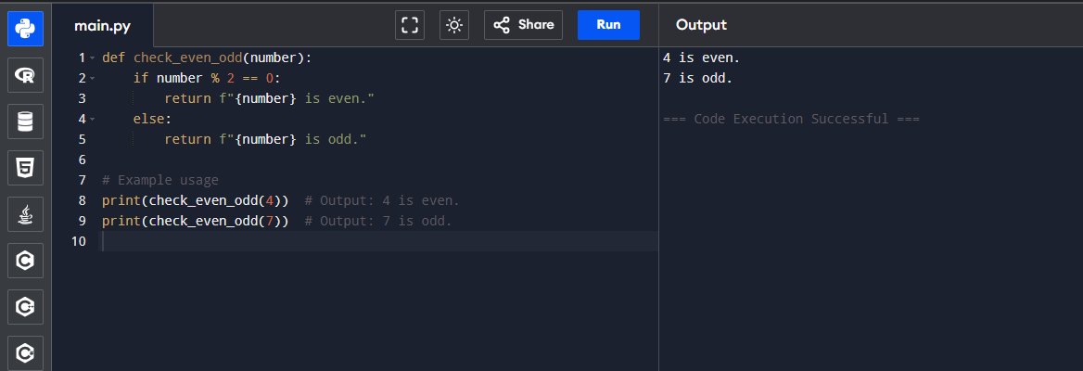

Task 3:

Write a function that takes a name and age and prints a greeting message to the user

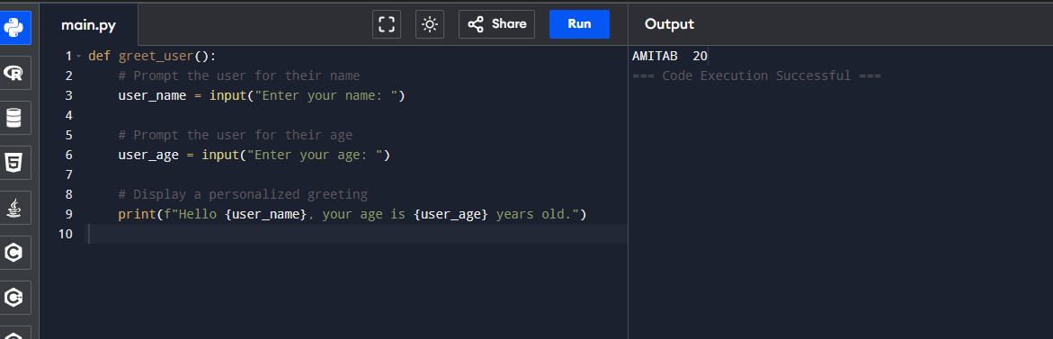

Lab 08 Task

Tasks:

Task 1: Make a calculator using the function the code should use only 2 operands(+ and -) for division and multiplication as well.

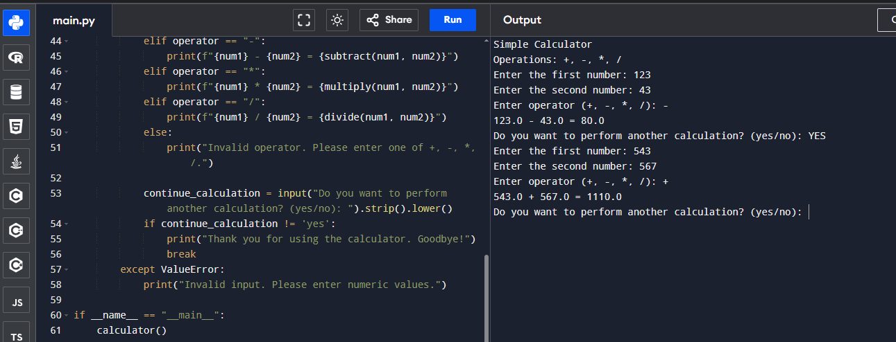

Task 2:

Write a functions that ask the user the shape and make the star shaped.

(Like it asks the shape(triangle or Rectangle) and make that shape

